Discussion post questions.

Week 4

- Describe some of the diet and health connections between a child and a senior citizen? Provide examples.

- Review the following case study from your text and respond to one question from Category A and one question from Category B.

Sarah is 28 years old and 7 months pregnant with her third child. Her other children are 2-1⁄2 and 1-1⁄2 years old. She had uncomplicated pregnancies and deliveries. Sarah is 5' 6" tall; she weighed 142 pounds at the beginning of this pregnancy, which made her prepregnancy BMI 23. She has gained 24 pounds so far. Prior to her first pregnancy, her BMI was 20 (124 pounds). She is unhappy about her weight gain, but the stress of having two young children and being a stay-at-home mom made losing weight impossible.
She went online for her MyPlate plan, which recommends she consume 2,400 calories per day. She doesn’t think she eats that much because she seems to have constant heartburn. She takes a prenatal supplement, so she feels confident that even if her intake is not perfect, she is getting all the nutrients she needs through her supplement.
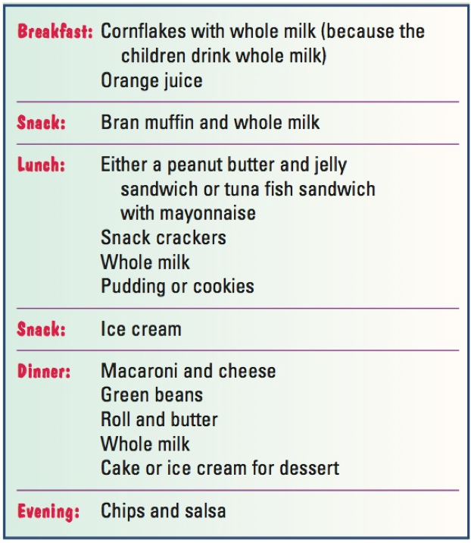
Category A
- Does she have any risk factors for a high-risk pregnancy? Explain your answer.
- Evaluate her prepregnancy weight and weight gain thus far. How much total weight should she gain? Explain your answer.
- Is her attitude about supplements appropriate? What would you tell her about supplements? Explain.

Category B
- Based on the 2,400-calorie meal pattern, what foods should Sarah eat more of? What food is she eating more than the recommended amounts? How would you suggest she modify her intake to minimize heartburn?
- What would you tell her about weight gain during pregnancy? What strategies would you suggest to her after her baby is born that would help her regain her healthy weight?
- Devise a 1-day menu for her that provides all the food she needs in the recommended amounts and alleviates her heartburn.

Week 5

- The following testimonial was posted on a clinic website (some information has been changed and/or edited to respect privacy). Read the statement and answer the questions that follow.

My daughter spent three weeks in an eating disorder medical stabilization unit in Phoenix, Arizona, for restrictive purging anorexia. She deteriorated physically as she intractably vomited everything she was encouraged to eat. She was refusing fluids as well. She fainted frequently with a resting heart rate between 35 and 45; they told me they could not help her. They would not place a life-sustaining NG-tube for fear of aspiration from her vomiting.
After my daughter spent almost two weeks in another hospital in Sacramento, vomiting NG-tubes out 7 or 8 times, the very desperate decision was made to surgically place a gastrostomy tube for life-saving nutrition. I was terrified at this aggressive measure, but I was also aware of the fact that my daughter was slipping away. The G-tube was placed and nutrition was given completely via the G-tube for 4 days.
Guess what? It broke the cycle of vomiting. She began to eat 100 percent without vomiting. The tube was used for a total of 5 days. Next, we began the hard work of refeeding together, FBT style. With the support of the doctors, nurses, aides, clerks, and therapists, we nursed my daughter back to physical stability. After almost 6 weeks, her G-tube was removed. She is weight restored and is fighting for her life now. She continues eating 100 percent of her three meals and her snack, and she shares more and more about how her anxiety rules her life.
- What are your thoughts on the treatment approach taken with the patient? What are the pros and cons of this approach? Explain.
- As a follow-up to this treatment, you are assigned to work with the patient and her family. What behavior modification techniques would you use and why?

Use evidence from one scholarly source other than your textbook to support your answer. Use APA format to cite your source.

2. What are the differences between enteral nutrition and total parenteral nutrition? How do the implications of each method concern the nurse?

Week 6

- Compare and contrast the effects of insulin and oral medications for type 1 and type 2 diabetics. What patient education is necessary?

Week 7

- Compare and contrast the types and levels of proteins necessary for renal patients with nephrotic syndrome, acute kidney disease, and chronic kidney disease.
- Explain options to improve oral intake for cancer and HIV/AIDS patients.

Week 8

Please respond to the following discussion prompt.
Visit the Mayo Clinic website and watch the video. [https://www.mayoclinic.org/diseases-conditions/heart-disease/multimedia/exercise-nutrition-myths-preventive-cardiology-video/vid-20138710] Answer the questions that follow.
- Do you question any of the information in the video? Do you feel the information is current and up to date? Why or why not?
- What new information did you learn?
- What information provided in the video is supported by your text?
- What are the primary factors that affect heart disease?

